**Digvijay Thakare   
Day 1 Assignment**

Que 1-Draw your Home Network Topology and explain how you are accessing the RPS Lab environment

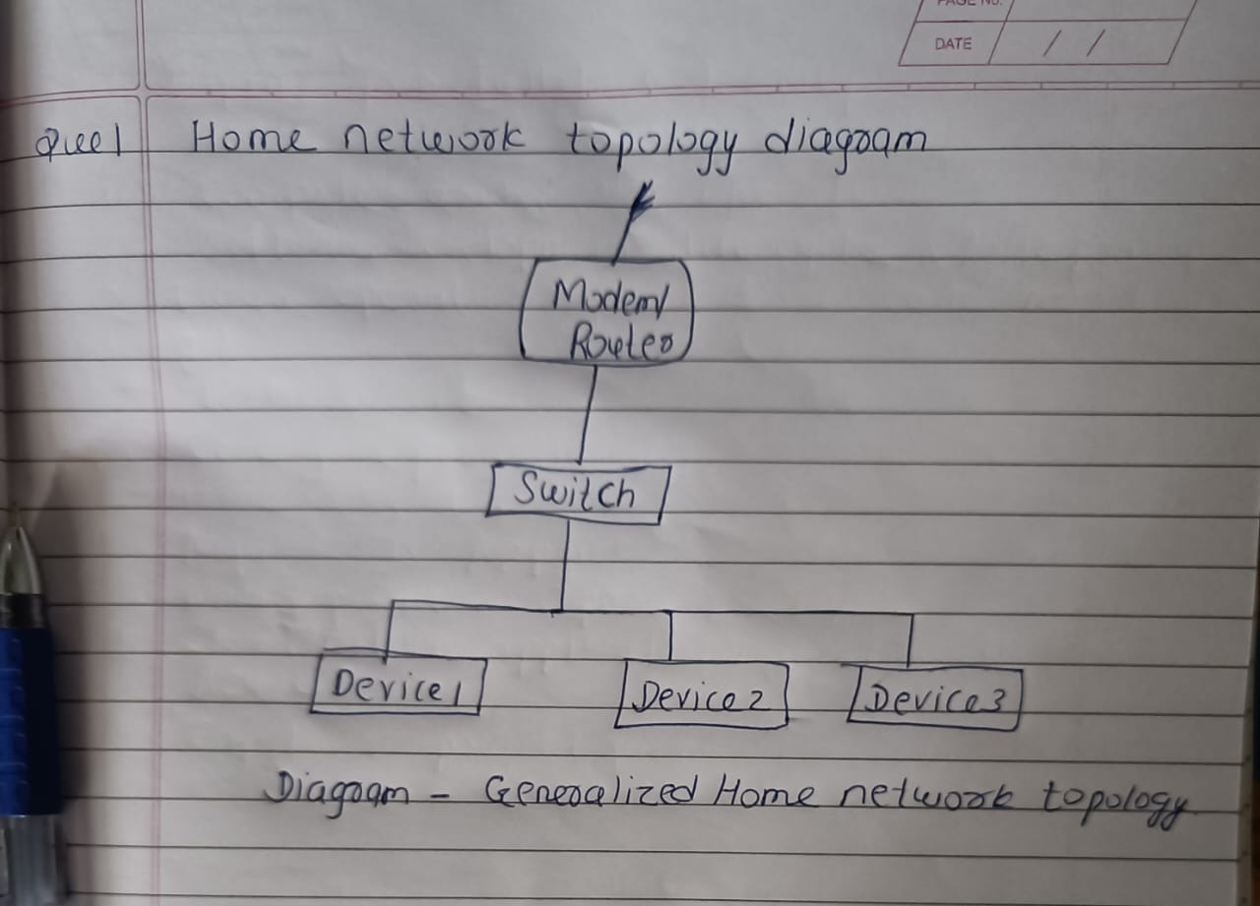

In this diagram:

* **ISP Modem/Router**: This is our internet service provider's modem/router device, which connects our home network to the internet.
* **Switch**: This is a networking device that allows multiple devices to connect to the network. It provides additional Ethernet ports for wired connections.
* When we attempt to access the cloud lab, our device sends a request to our router, which then goes out to the internet through our modem. The request travels across the internet to the cloud provider’s data center and reaches the specific server hosting our lab. The server processes the request and sends the response back through the same path to our device

**Assignment 2: Identify a real-world application for both parallel computing and networked systems. Explain how these technologies are used and why they are important in that context.**

**Ans-Real-world application for parallel computing: Weather Forecasting**

Explanation: Weather forecasting involves complex simulations of atmospheric conditions, which require significant computational power. Parallel computing allows weather forecasting models to break down these simulations into smaller tasks that can be processed simultaneously across multiple computing nodes. Each node can handle a portion of the simulation independently, speeding up the overall computation. This enables meteorologists to produce more accurate and timely weather forecasts, crucial for various industries like agriculture, transportation, and disaster preparedness.

Importance: Parallel computing enhances the scalability and efficiency of weather forecasting models, enabling meteorologists to analyze larger datasets and run more complex simulations. This leads to improved forecast accuracy, which in turn helps decision-makers and the general public make informed choices based on weather predictions, such as evacuating areas prone to natural disasters or optimizing crop planting schedules.

**Real-world application for networked systems:** Online Retail

**Explanation:** In online retail, networked systems play a vital role in managing various aspects of the business, including inventory management, order processing, customer relationship management (CRM), and website hosting. These systems rely on networked infrastructure to communicate and exchange data in real-time. For example, when a customer places an order on an e-commerce website, networked systems handle the transaction processing, inventory updates, and shipping logistics seamlessly across multiple interconnected servers and databases.

**Importance:** Networked systems enable online retailers to provide a seamless and responsive shopping experience to customers, regardless of the scale of operations. These systems facilitate efficient order processing, inventory tracking, and customer support, leading to increased customer satisfaction and loyalty. Additionally, networked systems allow retailers to scale their operations dynamically to meet changing demand, ensuring optimal performance during peak shopping seasons or promotional events.